

ASMA KHALID

01-134132-032

MUHAMMAD ABRAR-UL-HASSAN
01-134132-104

SnapIt, Face Gesture Recognition

Music Player

Bachelor of Science in Computer Science

Supervisor: Mr.Humayun Zaheer

Co-Supervisor: Dr. Muzammil

Department of Computer Science

Bahria University, Islamabad

April 2017

c Asma Khalid,Muhammad Abrar-ul-hassan, 2017

C e r t i f i c a t e

I, Asma Khalid and Muhammad Abrar-ul-hassan, declare that this thesis titled, ’SnapIt’ and the work presented in it are my own. I confirm that this work was done wholly or mainly while in candidature for a research degree at this University.Where any part of this thesis has previously been submitted for a degree or any other qualification at this University or any other institution, this has been clearly stated. Where I have consulted the published work of others, this is always clearly at-tributed. I have acknowledged all main sources of help.

Supervisor: Mr.Humayun Zaheer (Assistant Professor)

Co-Supervisor: Dr. Muzammil (Assistant Professor)

Internal Examiner: ()

External Examiner: ()

Project Coordinator: Dr.Arif ur Rehaman (Assistant Professor)

Head of the Department: Dr.Faisal Bashir (Associate Professor)

May 7st , 2017

Abstract

There will be solid proof for those widespread facial expressions of seven feelings anger, contempt, disgust, fear, joy, sadness, and astound. These 7 facial expressions would utilized within the production of facial identification provisions Furthermore face distinguishment frameworks. Eventually Tom’s perusing presenting an app that might consolidate those complexities of facial identification and the stimulation quality of a music player, those measurements and horizons about computerized reasoning. Com-pelling reason to the correct music at the good run through need been requested for quite a while presently and to days gone by few for decades simplicity about individual need been focusing on Previously, each result that is made.

i

ii

Acknowledgments

There are many efforts involved in the project by some individuals. First of all, we would like to acknowledge Mr.Humayun Zaheer who is our supervisor and inspiration behind this project. We would like to offer special thanks to Dr. Muzammil , who is our co supervisor, for the help he had offered throughout the complete process. More, we will like to acknowledge our head of department Mr. Faisal Bashir who was really a great motivation.

ASMA KHALID,MUHAMMAD ABRAR-UL-HASSAN

Islamabad, Pakistan

May 2017

iii

iv

Contents

Abstract |  |  |  | i
1 | Introduction |  |  | 1
 | 1.1 | Background . . . . . . . . . . . . . . . . . . . . . . . . . . . . . . . . . |  | 1
 | 1.2 | Introduction . . . . . . . . . . . . . . . . . . . . . . . . . . . . . . . . . |  | 1
 | 1.3 | Objective . . . . . . . . . . . . . . . . . . . . . . . . . . . . . . . . . . |  | 3
 |  | 1.3.1 | Academic Objective . . . . . . . . . . . . . . . . . . . . . . . . | 3
 | 1.4 | Problem Description . . . . . . . . . . . . . . . . . . . . . . . . . . . . |  | 3
 | 1.5 | Methodology . . . . . . . . . . . . . . . . . . . . . . . . . . . . . . . . |  | 4
 | 1.6 | Project Scope . . . . . . . . . . . . . . . . . . . . . . . . . . . . . . . . |  | 4
 | 1.7 | Solution Application Area . . . . . . . . . . . . . . . . . . . . . . . . . |  | 4
2 | Literature Review |  |  | 5
 | 2.1 | VLC . . . . . . . . . . . . . . . . . . . . . . . . . . . . . . . . . . . . . |  | 5
 | 2.2 | SnapChat . . . . . . . . . . . . . . . . . . . . . . . . . . . . . . . . . . |  | 5
 | 2.3 | Human Facial Expression Detection From Detected In Captured Image
 |  | Using Back Propagation Neural Network . . . . . . . . . . . . . . . . . |  | 5
 | 2.4 | Mood Based Music Player . . . . . . . . . . . . . . . . . . . . . . . . . |  | 8
 | 2.5 | Emotion Recognition . . . . . . . . . . . . . . . . . . . . . . . . . . . . |  | 8
 |  | 2.5.1 | Interpreting Results . . . . . . . . . . . . . . . . . . . . . . . . . | 8
3 | Requirement Specifications |  |  | 9
 | 3.1 | Functional Requirements . . . . . . . . . . . . . . . . . . . . . . . . . . |  | 9
 | 3.2 | Opening screen when SnapIt is installed . . . . . . . . . . . . . . . . . . |  | 9
 | 3.3 | Camera Screen . . . . . . . . . . . . . . . . . . . . . . . . . . . . . . . |  | 10
 | 3.4 | Music Player . . . . . . . . . . . . . . . . . . . . . . . . . . . . . . . . |  | 10
 | 3.5 | Playlists . . . . . . . . . . . . . . . . . . . . . . . . . . . . . . . . . . . |  | 10
 | 3.6 | Non-Functional requirements . . . . . . . . . . . . . . . . . . . . . . . . |  | 11
 |  | 3.6.1 | Availability . . . . . . . . . . . . . . . . . . . . . . . . . . . . . | 11
 |  | 3.6.2 | Efficiency . . . . . . . . . . . . . . . . . . . . . . . . . . . . . . | 11
 |  | 3.6.3 | Robustness . . . . . . . . . . . . . . . . . . . . . . . . . . . . . | 11
 |  | 3.6.4 | Reliability . . . . . . . . . . . . . . . . . . . . . . . . . . . . . . | 11
 |  | 3.6.5 | Modifiability(Future Updates) . . . . . . . . . . . . . . . . . . . | 11
 | 3.7 | Usecases . . . . . . . . . . . . . . . . . . . . . . . . . . . . . . . . . . . |  | 12

v

vi |  |  |  | CONTENTS
4 | System Design |  |  |  | 17
 | 4.1 | System Overview . . . . . . . . . . . . . . . . . |  | . . . . . . . . . . . . . | 17
 | 4.2 | System Architecture . . . . . . . . . . . . . . . . |  | . . . . . . . . . . . . . | 17
 | 4.3 | System Sequence Diagram . . . . . . . . . . . . |  | . . . . . . . . . . . . . | 19
 |  | 4.3.1 | Installation . . . . . . . . . . . . . . . . | . . . . . . . . . . . . . | 19
 |  | 4.3.2 | Camera screen . . . . . . . . . . . . . . | . . . . . . . . . . . . . | 20
 |  | 4.3.3 | Music Player . . . . . . . . . . . . . . . | . . . . . . . . . . . . . | 21
 |  | 4.3.4 | Playlists . . . . . . . . . . . . . . . . . . | . . . . . . . . . . . . . | 22
 | 4.4 | Class Diagram . . . . . . . . . . . . . . . . . . . |  | . . . . . . . . . . . . . | 23
 | 4.5 | Activity Diagrams . . . . . . . . . . . . . . . . . |  | . . . . . . . . . . . . . | 24
 |  | 4.5.1 | Installation . . . . . . . . . . . . . . . . | . . . . . . . . . . . . . | 24
 |  | 4.5.2 | Camera Screen . . . . . . . . . . . . . . | . . . . . . . . . . . . . | 25
 |  | 4.5.3 | Music Player . . . . . . . . . . . . . . . | . . . . . . . . . . . . . | 26
5 | System Implementation |  |  |  | 27
 | 5.1 | Tools and Techniques . . . . . . . . . . . . . . . |  | . . . . . . . . . . . . . | 27
 |  | 5.1.1 | Android Studio 2.3 . . . . . . . . . . . . | . . . . . . . . . . . . . | 27
 |  | 5.1.2 | Microsoft face detection/ Emotion APIs . | . . . . . . . . . . . . . | 28
 | 5.2 | Languages . . . . . . . . . . . . . . . . . . . . . |  | . . . . . . . . . . . . . | 28
 |  | 5.2.1 | Java . . . . . . . . . . . . . . . . . . . . | . . . . . . . . . . . . . | 28
 | 5.3 | Methodology . . . . . . . . . . . . . . . . . . . |  | . . . . . . . . . . . . . | 29
6 System Testing and Evaluation |  |  |  |  | 31
 | 6.1 | Functional Testing . . . . . . . . . . . . . . . . |  | . . . . . . . . . . . . . | 31
 |  | 6.1.1 | Unit Testing . . . . . . . . . . . . . . . . | . . . . . . . . . . . . . | 31
 |  | 6.1.2 | Integration Testing . . . . . . . . . . . . | . . . . . . . . . . . . . | 32
 |  | 6.1.3 | White Box Testing . . . . . . . . . . . . | . . . . . . . . . . . . . | 32
 |  | 6.1.4 | Black Box Testing . . . . . . . . . . . . | . . . . . . . . . . . . . | 32
 | 6.2 | Performance Testing . . . . . . . . . . . . . . . |  | . . . . . . . . . . . . . | 32
 | 6.3 | Acceptance Testing . . . . . . . . . . . . . . . . |  | . . . . . . . . . . . . . | 32
 | 6.4 | Test Cases . . . . . . . . . . . . . . . . . . . . . |  | . . . . . . . . . . . . . | 33
 |  | 6.4.1 | After Configuration . . . . . . . . . . . . | . . . . . . . . . . . . . | 33
 |  | 6.4.2 | Camera Screen . . . . . . . . . . . . . . | . . . . . . . . . . . . . | 33
 |  | 6.4.3 | Music Player . . . . . . . . . . . . . . . | . . . . . . . . . . . . . | 33
 |  | 6.4.4 | Playlists . . . . . . . . . . . . . . . . . . | . . . . . . . . . . . . . | 34
7 | Conclusions |  |  |  | 35
 | 7.1 | Conclusion . . . . . . . . . . . . . . . . . . . . |  | . . . . . . . . . . . . . | 35
References |  |  |  |  | 37

List of Figures

2.1 | Five Modules of System . . . . . . . . . . . . . . . . . . . . . . . . . . |  | 6
2.2 | Five Modules of System . . . . . . . . . . . . . . . . . . . . . . . . . . |  | 7
3.1 | UC-1.01 | General Usecase . . . . . . . . . . . . . . . . . . . . . . . . . . | 12
3.2 | UC-1.02 | Camera Screen Usecase . . . . . . . . . . . . . . . . . . . . . . | 13
3.3 | UC-1.03 | Music Player Usecase . . . . . . . . . . . . . . . . . . . . . . . | 14
3.4 | UC-1.04 | Playlists . . . . . . . . . . . . . . . . . . . . . . . . . . . . . . | 15
4.1 | Basic System Architecture . . . . . . . . . . . . . . . . . . . . . . . . . |  | 18
4.2 | Installation Sequence Diagram . . . . . . . . . . . . . . . . . . . . . . . |  | 19
4.3 | Camera Screen Sequence Diagram . . . . . . . . . . . . . . . . . . . . . |  | 20
4.4 | Music Player Sequence Diagram . . . . . . . . . . . . . . . . . . . . . . |  | 21
4.5 | Play List Sequence Diagram . . . . . . . . . . . . . . . . . . . . . . . . |  | 22
4.6 | Class Diagram . . . . . . . . . . . . . . . . . . . . . . . . . . . . . . . |  | 23
4.7 | Installation Activity Diagram . . . . . . . . . . . . . . . . . . . . . . . |  | 24
4.8 | Camera Screen Activity Diagram . . . . . . . . . . . . . . . . . . . . . . |  | 25
4.9 | Play List Activity Diagram . . . . . . . . . . . . . . . . . . . . . . . . . |  | 26
5.1 | Methodology . . . . . . . . . . . . . . . . . . . . . . . . . . . . . . . . |  | 29

vii

viii LIST OF FIGURES

List of Tables

3.1 | Identifier R1 . . . . . . . . . . . . . . . . . . . . . . . . . . . . . . . . . | 9
3.2 | Identifier R2 . . . . . . . . . . . . . . . . . . . . . . . . . . . . . . . . . | 10
3.3 | Identifier R3 . . . . . . . . . . . . . . . . . . . . . . . . . . . . . . . . . | 10
3.4 | Identifier R4 . . . . . . . . . . . . . . . . . . . . . . . . . . . . . . . . . | 10
3.5 | Use Case-1.01: Installation . . . . . . . . . . . . . . . . . . . . . . . . . | 13
3.6 | Use Case-1.02: Camera Screen . . . . . . . . . . . . . . . . . . . . . . . | 14
3.7 | Use Case-1.03: Music Player Usecase . . . . . . . . . . . . . . . . . . . | 15
3.8 | Use Case-1.03: Music Player Usecase . . . . . . . . . . . . . . . . . . . | 16
6.1 | Test Case-1: After Configuration . . . . . . . . . . . . . . . . . . . . . . | 33
6.2 | Test Case-2: Camera Screen . . . . . . . . . . . . . . . . . . . . . . . . | 33
6.3 | Test Case-3: Music Player . . . . . . . . . . . . . . . . . . . . . . . . . | 34
6.4 | Test Case-4:Playlist . . . . . . . . . . . . . . . . . . . . . . . . . . . . . | 34

ix

x LIST OF TABLES

Chapter 1

Introduction

1.1 Background

There will be solid proof for those widespread facial expressions of seven feelings – anger, contempt, disgust, fear, joy, sadness, and astound. These 7 facial expressions would utilized within the production of facial identification provisions Furthermore face distinguishment frameworks. Eventually Tom’s perusing presenting an app that might consolidate those complexities of facial identification and the stimulation quality of a music player, those measurements and horizons about computerized reasoning. Compelling reason to the correct music at the good run through need been requested for quite a while presently and to days gone by few for decades simplicity about individual need been focusing on Previously, each result that is made.

1.2 Introduction

Throughout as far back as two decades, facial outflow distinguishment need pulled in a stupendous enthusiasm toward the exploratory community, Concerning illustration it assumes An enter part over mankind’s focused interfaces. Facial distinguishment (or face recognition) will be a biometric system for distinguishing a distinctive by thinking about live catch alternately advanced picture information with the put away record to that man. A large number applications, for example, virtual reality, videoconferencing, client profiling, and client fulfillment investigations for show What’s more web services, require proficient facial outflow distinguishment in place will accomplish those wanted effects. Music may be characteristically interweaved with our normal an aggregation. Individuals have a tendency to utilize music in the morning on smoothness finish their chores, to release it then afterward fill in What’s more with make it through a preparing chance. People utilization music same time Taking in What’s more surgeons with music in the foundation perform their vast majority escalated consideration methods. Basically,

1

2 Introduction

individual’s utilization music should enhance their temperament. Sure condition of brain builds force of invention, enhances choice making process, and What’s more strengthens social associations. Moreover, certain state of brain lightens us starting with the stress, which might generally have a harming impact around our wellbeing Also prosperity. The thought is on mechanize the associations the middle of the clients what’s more music player, something like that Likewise on gatherings give an easy to understand earth. Practically present facial distinguishment frameworks fill in with numeric codes known as face prints. Such frameworks recognize 80 nodal focuses with respect to a human face. In this context, nodal focuses would wind focuses used to measure variables of a person’s face, for example, the period alternately width of the nose, the profundity of the eye sockets and the state of the cheekbones. These frameworks worth of effort toward catching information to nodal focuses around An advanced picture for an individual’s face and storing the coming about information Concerning illustration a face print. The face print might that point a chance to be utilized Concerning illustration a support for correlation with information caught from confronts in an picture alternately feature.

This venture introduces a music player which takes in every last one of preferences, feelings Furthermore exercises of a client Furthermore customizes its tune determination as needs be. Those Different facial expressions for clients might be recorded Eventually Tom’s perusing those contraption on figure out the feeling of the client in that occurrence along these lines Similarly as should foresee the kind of the music. Those requirement will diminish the measure about seeking it takes to discover An tune clinched alongside our playlist need quickly grown, Previously, falling flat on do In this way it need Rather pulled in dissatisfaction. The extent to which simpler will it get to some way or another subsume those perfect of a music player, face gesture distinguishment What’s more showing the suitable playlist under one provision. An bisexuality built app that won’t best decline the measure about seeking through our playlist on discover those right melody as well as diminish those dissatisfaction from claiming not discovering a melody Similarly as before long as time permits. An music player that camwood recognize your facial gestures (raising your eyebrows, opening your mouth , tilting your head, etc) ,each gesture will need an alternate temperament designated on it, What’s more display you with an accumulation about tunes which need aid as stated by that temperament and the client could effortlessly filter through the individuals tunes. The center purpose from claiming SnapIt will make to distinguish facial gestures caught front cam for their bisexuality units and exhibit the client with a playlist fulfilling the user’s temperament. The human face is a critical a piece about a singular’s form Furthermore it particularly assumes a paramount part to comprehending A singular’s temperament. Extracting those required information from the human face camwood notwithstanding be done straightforwardly utilizing a Polaroid. This enter could At that point a chance to be utilized from various perspectives. A standout amongst the requisitions from claiming this information camwood be for extracting the majority of the
1.3 Objective | 3

data with find those temperament from claiming a distinct. This information camwood after that make used to get a rundown of tunes that go along with the „mood determined from those information furnished prior. This dispenses with those time consuming Also repetitively undertaking for manually segregating or grouping tunes under separate records Furthermore aides On generating a proper playlist In view of A singular’s passionate features. Different calculations have been produced and recommended for computerizing the playlist era procedure. Facial outflow built music Player expects at filtering also translating the information Also Appropriately making a playlist based those parameters furnished. The filtering and translating incorporates sound characteristic extraction What’s more arrangement should get a rundown about tunes having a place with a comparable kind alternately should get a rundown of comparative sounder tunes. An app that utilization face identification and facial Characteristics will focus those user’s temperament Also In view of this, those app will display those client for An customize predefined playlist.

1.3 Objective

A music player that presents a predefined playlist based on your mood after evaluating user’s facial gestures.

1.3.1 Academic Objective

To learn how to apply the concepts learned from the course work, to solve the practical problems and to explore how to research and learn new tools and technologies that are expected of a fresh graduate in the practical industry.

1.4 Problem Description

SnapIt will minimize time it gets a person to fish out a song from his/her playlist which would be according to his/her need. Instead of manually searching the whole playlist, user can easily have an array of songs or music presented on the screen which is according to the user’s mood. Emotion based music retrieval is a music player based on user’s emotion. Many music devices and mobile music players are used to listen to music. A practical problem is selection of desired music. n. Users can search through music collection based on emotional character of music which expressed from facial gestures. The main aim of this project is to design emotion based user interface for music retrieval. The main concern for SnapIt is the face detection part. Instead of using the face detection in digital image processing, we will be using Data Mining tool to determine the face and the movement of facial features to detect the required gestures. It is very important to tell that SnapIt will
4 Introduction

not be recognizing the face through the live camera but rather detecting the face using the camera and the APIs used by the face++ libraries.

1.5 Methodology

The basic idea with creating SnapIt is to immerse data mining tools with programming (preferably C). A newly emerging trend, claimed to achieve improved accuracies, is three-dimensional face recognition. This technique uses 3D sensors to capture information about the shape of a face. This information is then used to identify distinctive features on the surface of a face, such as the contour of the eye sockets, nose, and chin. The general steps that would be taken to create this app are as follows:

- Creating interface for capturing a video using the front cam.

- Segment a face out of it. (Using Microsoft API)

- Extract facial features (e.g chin, mouth, eye, geometery)

- Build a classifier that can be trained based on the features. (Decision tree ID3)

- Write a music player with playlist support.

- Create interface for separate playlists.

- Create links between the multiple interfaces.

1.6 Project Scope

SnapIt will completely eliminate the need to check the playlist manually to find a song appropriate to user’s mood. SnapIt will be completed with a basic structure when the app will automatically recognize the user’s mood by sensing the gestures and delivering the user with a playlist which is required by the user. The estimated time frame to create a prototype will be five to six months. This prototype will be a complete working structure of the app, which could be further enhanced in due course.

1.7 Solution Application Area

Everyday users who need a new source of entertainment as well as an ease when it comes to browsing a song in their playlist that would contain hundreds of songs. It is also an indirect way of organizing playlist according to the mood preference. The target audience would of course be the youngsters but could be enjoyed by other age groups. SnapIt will be most beneficial to people commuting to and fro as they can easily browse through their playlist while driving.

Chapter 2

Literature Review

2.1 VLC

VLC media player is a free and open source media player, encoder, and streamer made y the volunteers of the VideoLAN community. VLC uses internal codecs, works on essentially every popular platform, and can read almost all files, CDs, DVDs, networks streams, capture cards and other media formats.[1].

2.2 SnapChat

Snapchat is both a messaging platform and a social network. It can’t be used from the regular we and exists only as a mobile app you can download to your iPhone or Android smartphone. Users can “chat” with their friends by sending those photos, short videos up to 10 seconds long. You can sort of think of it to be like texting with pictures or videos. Text chats and video calls are two other features that were added more recently to the app. One of the most unique things about Snapchat is the ephemeral components of all the content that gets shared on it. Photos and videos essentially disappear a few seconds after they’ve been viewed by their recipients. Unlike other social networks, which keep your content online forever unless you decide to delete it, Snapchat’s disappearing content makes online interaction feel more human and a little more grounded in the present moment.[2].

2.3 Human Facial Expression Detection From Detected In Captured

Image Using Back Propagation Neural Network

In the field of image processing it is very interesting to recognize the human gesture for general life applications. Human gestures can be identified by observing the different movements of eyes, mouth, nose and hands. Human facial gestures recognition by the ma-chine can be describes as an interpretation of human facial characteristics via mathematical

5

6 Literature Review

algorithms. Gestures of the body are read by an input sensing device such as the front cam of an android device. It reads the movements of the face and communicates at the back end and uses these gestures as input. These gestures are then interpreted using algorithm either based on statistical analysis or artificial intelligence techniques. The primary goal of gesture recognition research is to create a system which can identify specific human gestures and use them to convey information. By observing face, one can decide whether a man is serious, happy, thinking, sad, feeling pain and so on. The proposed system is divided into five modules:
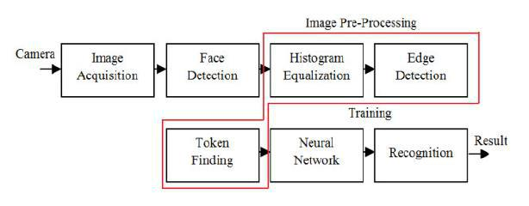

Figure 2.1: Five Modules of System

Each box is treated as one module. The first module captures the image using the front cam. Second module is for face detection which can detect the human face from the captured image. A set of modules bounded by a boundary line represent pre-processing block. It consists of histogram equalization, edge detection, thinning and the token generation modules. The next module is the training module to store the token information
2.3 Human Facial Expression Detection From Detected In Captured Image Using Back
Propagation Neural Network | 7

that comes from the image pre-processing block module. This training had been done using back propagation neural network. And the last module is the token matching and decision making called recognition module which produces the final result. The following flowchart represents how all the modules work.
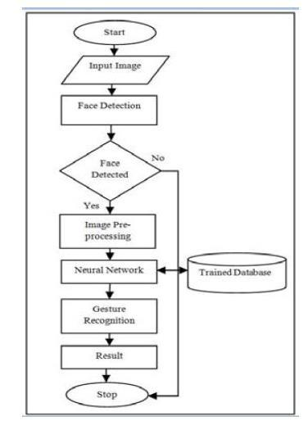

Figure 2.2: Five Modules of System

8 Literature Review

2.4 Mood Based Music Player

The human face is an important part of an individual’s body and it especially plays an important role in knowing an individual’s mood. Extracting the required input from the human face can now be done directly using a camera. This input can then be used in many ways. One of the applications of this input can be for extracting the information to deduce the mood of an individual. This data can then be used to get a list of songs that comply with the mood derived from the input provided earlier. This eliminates the time-consuming and tedious task of annually Segregating or grouping songs into different lists and helps in generating an appropriate playlist based on an individual’s emotional features. Various algorithms have been developed and proposed for automating the playlist generation process. Facial Expression Based Music Player aims at scanning and interpreting the data and accordingly creating a playlist based the parameters provided. The scanning and interpreting includes audio feature extraction and classification to get a list of songs belonging to a similar genre or to get a list of similar sounding songs.

2.5 Emotion Recognition

The Emotion API beta takes an image as an input, and returns the confidence across a set of emotions for each face in the image, as well as bounding box for the face, from the Face API. The emotions detected are happiness, sadness, surprise, anger, fear, contempt, disgust or neutral. These emotions are communicated cross-culturally and universally via the same basic facial expressions, where are identified by Emotion API.

2.5.1 Interpreting Results

In interpreting results from the Emotion API, the emotion detected should be interpreted as the emotion with the highest score, as scores are normalized to sum to one. Users may choose to set a higher confidence threshold within their application, depending on their needs. For more details about emotion detection, please refer to the API Reference:

Basic: If a user has already called the Face API, they can submit the face rectangle as an input and use the basic tier.

Standard: If a user does not submit a face rectangle, they should use standard mode.

Chapter 3

Requirement Specifications

3.1 Functional Requirements

The official definition of a functional requirement is that it essentially specifies something the system should do. Typically, functional requirement will specify a behavior of function. Practical prerequisites would the individuals necessities that need aid finishing those fundamental partake energizes the requisition What’s more because of which a provision will be known as. Here need aid a portion of the practical prerequisites of the requisition which are the principle modules Also that need aid completing those fill in which is the primary characteristic from claiming SnapIt][3].

3.2 Opening screen when SnapIt is installed

Identifier | R1
Title | Installation
Requirements | Front camera , complete playlist in phone storage
Rationale | To assign separate songs to each of the three moods. i.e sad happy and soothing.
Restrictions and Risks | Front camera should be working and app should have access to the music library
Dependencies | User has complete control over the music library
Priority | High
 | Table 3.1: Identifier R1

Requirements for the Installation or configuration screen are that the front camera should be operable and the playlist on the user’s phone should be syned. On this screen the user will populate the songs in the playlists.

9

10 Requirement Specifications

3.3 Camera Screen

Camera screen requirements are that the front cam of the user’s phone should be operable as it will be used to detect the facial gestures.

Identifier |  | R2
Title |  | Camera Screen
Requirements |  | Operable front camera of the android device
Rationale |  | Camera screen will detect the facial gestures.
Restrictions and Risks |  | Facial gestures may not be detected
Dependencies |  | Facial Gestures
Priority |  | High
 | Table 3.2: Identifier R2

3.4 Music Player

Identifier | R3
Title | Music Player
Requirements | Access over the entire music library
Rationale | Music player with the facility to play,pause,stop, backward, forward and volume options.
Restrictions and Risks | Music player must have access over the entire music library in user’s phone
Dependencies | R2
Priority | High
 | Table 3.3: Identifier R3

Requirements for the music player are that application should be given authority to access the music library. Playlists should be populated at the time of installation or configuration.

3.5 Playlists

Identifier | R4
Title | Playlists
Requirements | Access to mobile storage of the user’s cell phone
Rationale | Playlists will be created. Every mood will have its own playlist created at the time of installat
Restrictions and Risks | Playlist should be properly maintained and must have access to camera, music player as well
Dependencies | Music library of the user, R1
Priority | High

Table 3.4: Identifier R4

3.6 Non-Functional requirements | 11

Requirement for the playlists are that application should have access over the android device’s complete mobile storage to populate the playlists.

3.6 Non-Functional requirements

Non-functional requirements describes how the system should behave and that that is a constraint upon the systems behavior. One could also think of non-functional requirements as quality attributes for a system.

3.6.1 Availability

This a standalone application and will be available when the user will trigger.

3.6.2 Efficiency

Framework will guarantee effectiveness toward giving work to quick answer for at modules.

3.6.3 Robustness

Framework administers its own stockpiling and also every last one of playlists made during the chance from claiming establishment would put away in the device’s memory[4].

3.6.4 Reliability

Framework will guarantee the high-keyed unwavering quality concerning illustration it will be constructed on the propelled efforts to establish safety Concerning illustration it is crucial on stay with the face identification totally impartial Furthermore nothing starting with whatever interloper attackers[5].

3.6.5 Modifiability(Future Updates)

There would huge numbers specific things the place we might include other features. Thereabouts with those section for run through we will would that and also blacks. I. E: expansion from claiming a greater amount whimsical qualities which might a chance to be advantageous on an excitement level and expansion from claiming All the more moods. Graphical interface might additionally make improved[6].
12 Requirement Specifications

3.7 Usecases
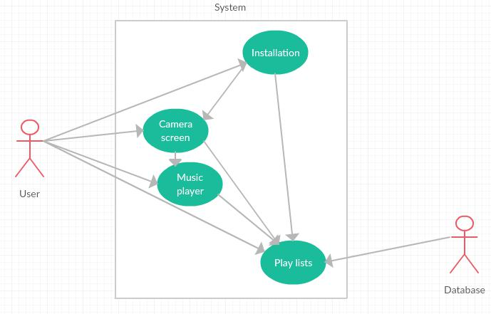

Figure 3.1: UC-1.01 General Usecase

General use case shows that the actors involved in this application are User (who are using the app) and the database (storage memory for the facial gesture to go in link with the playlists). UC-1.01 shows the actor involved is the user who would populate the playlist and move onto camera screen at this screen. As this is the configuration screen, the major work done is the populating of the playlists one by one. Each emotion has to have a different playlist. Every emotion playlist is populated by selected the emotion and a screen with a list of songs would appear. These songs are the complete collection from the device memory, then respective songs are selected for that emotions and next button is clicked. This process is completed for all of the emotions.
3.7 Usecases | 13
Use Case Id | UC-1.01
Use Case Name | Installation
Actors | User
Description | User Shall be able to create playlists according to each mode
Trigger | User clicks on mood drop down menu and select songs for that mood.
Pre-Conditions | Music library should be accessible.
Post-Conditions | Successful selection of songs for each mood.
Normal Flow | Select mood from menu. Select songs for that particular mood from selection menu.
Alternative Flows | None
Exceptions | None
Includes | None
Special requirements | Music library of user’s android device must be in sync.
Assumptions | None
Notes and issues | None
 | Table 3.5: Use Case-1.01: Installation
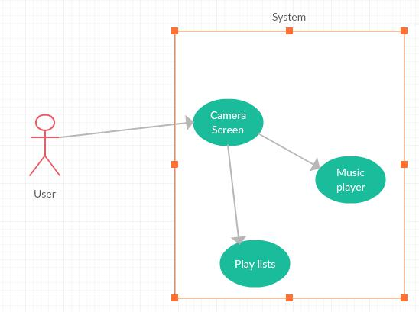

Figure 3.2: UC-1.02 Camera Screen Usecase

14 |  |  | Requirement Specifications
 | Use Case Id |  | UC-1.02
 | Use Case Name |  | Camera Screen
 | Actors |  | User
 | Description |  | User shall be able to get face detected via front camera.
 | Trigger |  | User clicks on camera button to start the face detection.
 | Pre-Conditions |  | Front camera must be synced up.
 | Post-Conditions |  | Face is detected successfully and the mood is recognized.
 | Normal Flow |  | Camera button is pressed,Face is detected,Mood is recognized.
 | Alternative Flows |  | None
 | Exceptions |  | None
 | Includes |  | None
 | Special requirements |  | Music library of user’s android device must be in sync.
 | Assumptions |  | None
 | Notes and issues |  | None
 |  | Table 3.6: Use Case-1.02: Camera Screen

UC-1.02 shows that the actor involved is the user and the screen would be available to start the camera and click the picture for the recognition of the mood.
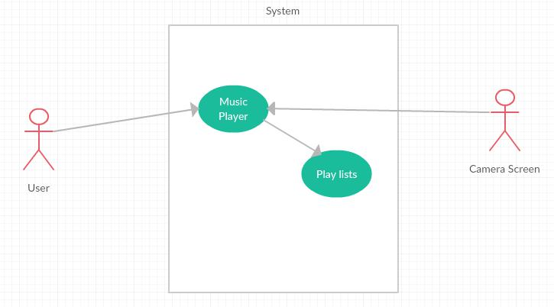

Figure 3.3: UC-1.03 Music Player Usecase

3.7 Usecases | 15
Use Case Id | UC-1.03
Use Case Name | Music Player
Actors | User,Camera Screen
Description | Music is played after the right playlist is automatically chosen based on user’s facial ges
Trigger | Basic functionalities of a music player i.e play, pause, stop, next, back volume.
Pre-Conditions | There should be at least one playlist stored for the player to start playing music.
Post-Conditions | Music is played successfully.
Normal Flow | Choosen playlist is played,pause,play, next song,previous,start and stop song buttons
Alternative Flows | None
Exceptions | None
Includes | An option to scroll through the playlist.
Special requirements | There must be at least songs in the playlist
Assumptions | None
Notes and issues | None
 | Table 3.7: Use Case-1.03: Music Player Usecase
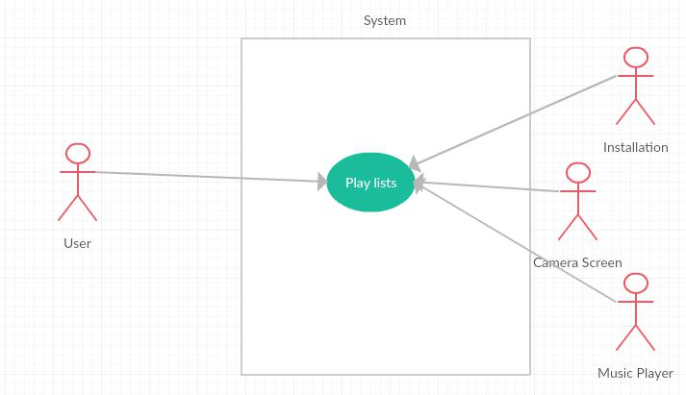

Figure 3.4: UC-1.04 Playlists

16 | Requirement Specifications
Use Case Id | UC-1.04
Use Case Name | Playlists
Actors | User,System
Description | Three individual playlists are stored here, one for each mood.
Trigger | Can be accessed through music player. Scroll option is there for each playlist
Pre-Conditions | There should be at least one song present in any one playlist.
Post-Conditions | Music playlists are accessible and can be browsed by the user.
Normal Flow | Open playlist through music player, Scroll through the selected playlist.
Alternative Flows | None
Exceptions | None
Includes | An option to scroll through other playlists.
Special requirements | There must be at least songs in the playlist
Assumptions | None
Notes and issues | None
 | Table 3.8: Use Case-1.03: Music Player Usecase

UC-1.04 shows user, installation, music player and the playlist as the actors as all of them affect or are affected by the playlists. This screen basically allows the user to scroll through the playlists.

Chapter 4

System Design

4.1 System Overview

SnapIt will minimize duration of the time it gets an individual with fish out a melody starting with his/her playlist which might a chance to be as stated by his/her necessity. As opposed to manually looking those entire playlist, client could effortlessly have an exhibit from claiming tunes or music introduced on the screen which will be as stated by those user’s temperament. Feeling built music recovery will be a music player In view of user’s feeling. A lot of people music gadgets and portable music players are used to tune in to music. A useful issue will be Choice for fancied music. N. Clients camwood scan through music gathering In view of enthusiastic character for music which communicated starting with facial gestures. Those principle point about this task will be on plan feeling built client interface to music recovery. Those primary worry to SnapIt will be those face identification piece. As opposed to utilizing those face identification. Previously, advanced picture processing, we will a chance to be utilizing information mining apparatus on determine those face and the development for facial Characteristics on identify the required gestures[6].

4.2 System Architecture

To object-oriented modifying development, model-view-controller (MVC) is the sake of a procedure alternately outline example to effectively Also proficiently relating those client interface with underlying information models. Those MVC design is broadly utilized within project advancement for modifying dialects for example, such that Java, Smalltalk, C, What’s more C++. The MVC design need been proclaimed toward A large number developers Likewise a suitable example to the reuse about article code also a design that permits them on altogether diminish the duration of the time it takes to create provisions with client interfaces. Those model-view-controller example proposes three primary parts

17

18 System Design

alternately questions with be utilized within product development: A Model: which speaks to those underlying, legitimate structure from claiming information done a programming provision and the high-keyed population connected with it. This article model doesn’t hold numerous whatever majority of the data something like the client interface. A View: which will be an accumulation for classes speaking to the components in the client interface (all of the things those client could view Furthermore react with on the screen, for example, such that buttons, show boxes, along these lines forth). A Controller: which speaks to the classes interfacing the model and the view, also will be used to correspond the middle of classes in the model What’s more perspective.
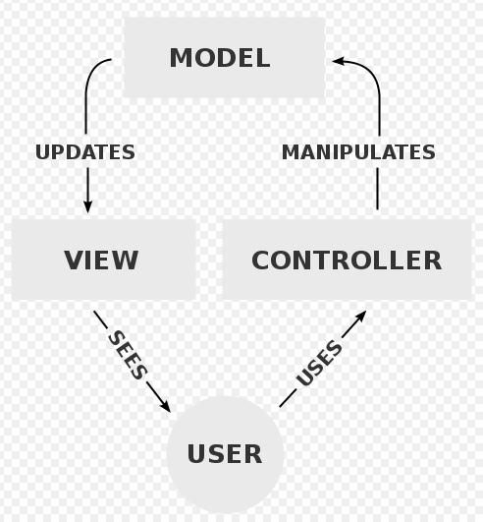

Figure 4.1: Basic System Architecture

4.3 System Sequence Diagram 19

4.3 System Sequence Diagram

4.3.1 Installation
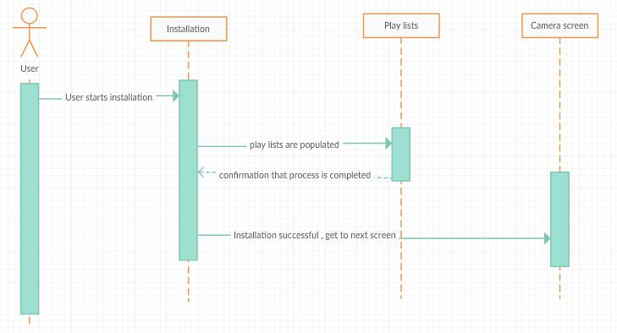

Figure 4.2: Installation Sequence Diagram

In this sequence diagram, it is displayed that the user will start up the installation process and populate the lists, and after the installation or configuration process user can move on to the next screen.

20 System Design

4.3.2 Camera screen
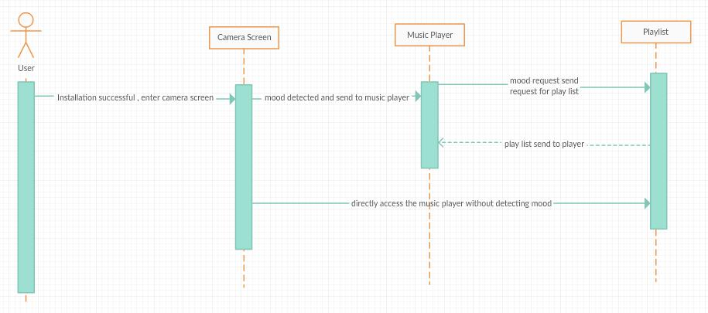

Figure 4.3: Camera Screen Sequence Diagram

In this diagram, it is displayed that the user has successfully completed the configuration process. Camera detects the mood and the relevant playlist is selected and played through the music player.

4.3 System Sequence Diagram 21

4.3.3 Music Player
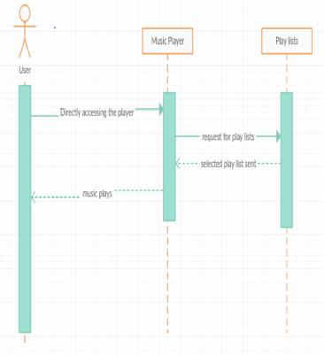

Figure 4.4: Music Player Sequence Diagram

This sequence diagram shows, that the user can also directly access the music player and play a song of choice without the recognition process.

22 System Design

4.3.4 Playlists
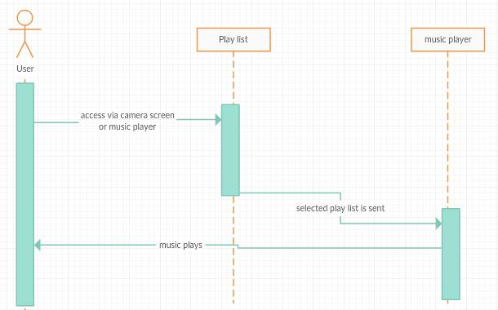

Figure 4.5: Play List Sequence Diagram

This diagram shows that the user can insert or select a song in the playlist. User can scroll through the playlists.

4.4 Class Diagram | 23

4.4 Class Diagram
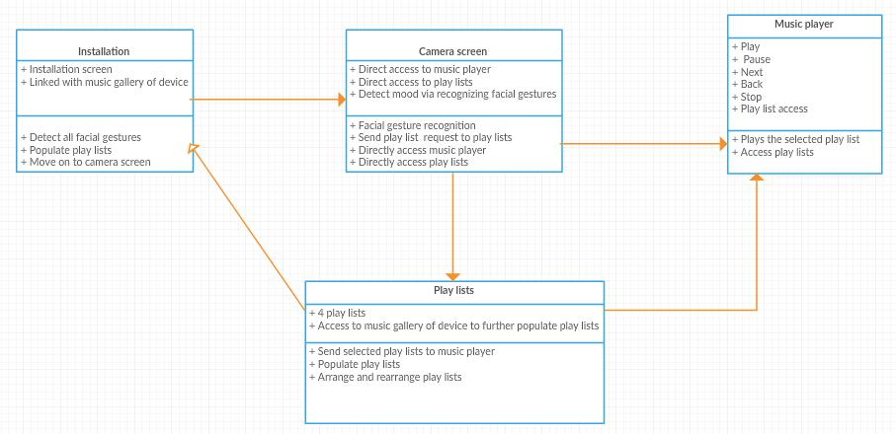

Figure 4.6: Class Diagram

This class diagram shows the overall working and relationships between all the interfaces and how they are connected and what working they are performing. Installation has the direct link to the camera screen. Camera screen can be used to access the playlist and music player directly. Music player and playlists then can be directly accessed by the user.
24 System Design

4.5 Activity Diagrams

4.5.1 Installation
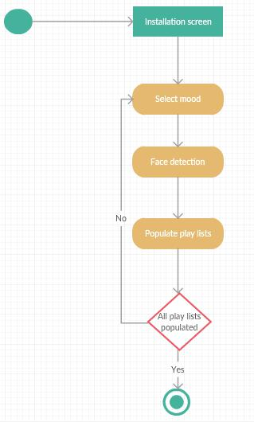

Figure 4.7: Installation Activity Diagram

This diagram shows the process of the list being populated emotion by emotion and moving on to next step after all the playlists are populated.

4.5 Activity Diagrams 25

4.5.2 Camera Screen
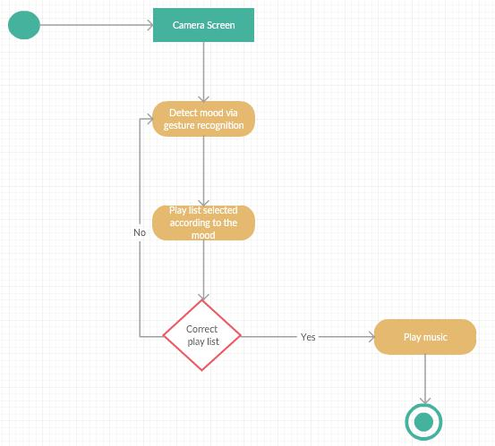

Figure 4.8: Camera Screen Activity Diagram

In this diagram it is displayed that the user music player either gets the playlist via camera screen or manually and then that playlist is played.

26 System Design

4.5.3 Music Player
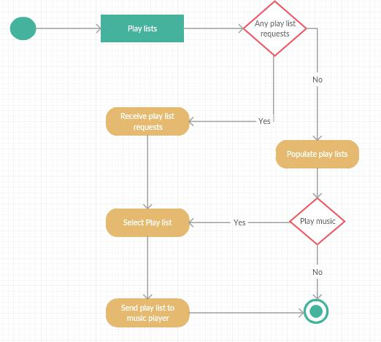

Figure 4.9: Play List Activity Diagram

In this diagram it is displayed that the user can play a playlist manually only if the playlists are populated otherwise the playlists have to be populated first and then played.

Chapter 5

System Implementation

In this chapter, we will talk about the tools and technologies, the libraries and algorithm that were used in development of system. As discussed beforehand, we have 4 main modules of system[7].

Opening screen when Snapit is installed. Camera screen
Music Player Playlist

5.1 Tools and Techniques

5.1.1 Android Studio 2.3

Android Studio is the official Integrated Development Environment (IDE) for Android app development, based on IntelliJ IDEA. On top of IntelliJ’s powerful code editor and developer tools, Android Studio offers even more features that enhance your productivity when building Android apps, such as:[8].

A flexible Gradle-based build system. A fast and feature-rich emulator

A unified environment where you can develop for all Android devices

Instant Run to push changes to your running app without building a new APK

Code templates and GitHub integration to help you build common app features and import sample code

Extensive testing tools and frameworks.

27

28 System Implementation

Lint tools to catch performance, usability, version compatibility, and other problems

C++ and NDK support

Built-in support for Google Cloud Platform, making it easy to integrate Google Cloud Messaging and App Engine

We are using Android studio as the basic tool as our whole application is developed in Android studio. It provides us with easy accessibility over the interface and the back end. It also provides with easy connectivity between the application and different APIs[9]

5.1.2 Microsoft face detection/ Emotion APIs

The Emotion API takes a facial expression in an image as an input, and returns the confidence across a set of emotions for each face in the image, as well as bounding box for the face, using the Face API. If a user has already called the Face API, they can submit the face rectangle as an optional input. The emotions detected are anger, contempt, disgust, fear, happiness, neutral, sadness, and surprise. These emotions are understood to be cross-culturally and universally communicated with particular facial expressions.

5.2 Languages

5.2.1 Java

For development of this application we have used JAVA primarily. Java is a general-purpose computer programming language that is concurrent, class-based, object-oriented, and specifically designed to have as few implementation dependencies as possible. It is intended to let application developers “write once, run anywhere” (WORA), meaning that compiled Java code can run on all platforms that support Java without the need for recompilation[4].
5.3 Methodology 29

5.3 Methodology
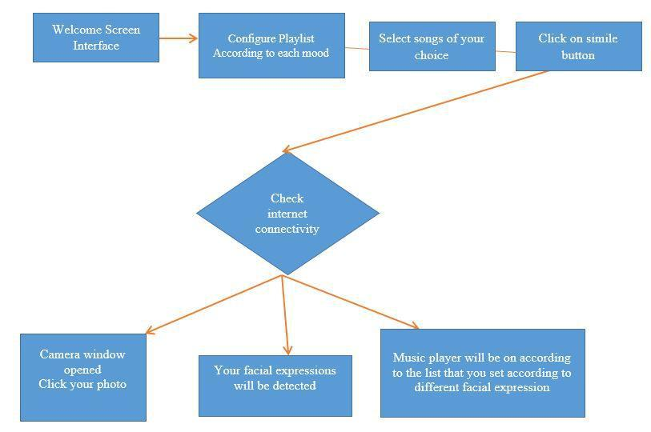

Figure 5.1: Methodology

30 System Implementation

Chapter 6

System Testing and Evaluation

Software testing is a whole process of executing a program with the intended result to be of finding the bugs. It can also be explained as the procedure of validating and verifying that a software program or application or product: Meets the business and technical requirements that guided its design and development. Techniques for software testing for applications are:[10].

Fundamental Testing Performance Testing Acceptance Testing

6.1 Functional Testing

Functional testing of application has only concern with the functionality of application. Functional testing is perform by giving the inputs to the function and gets the output. Then check whether the output is correct according to the input or output in incorrect. The types of functional requirements are:

unit Testing

Integration Testing Black Box Testing White Box Testing

6.1.1 Unit Testing

In unit testing the system is divided into small modules and then test each module to verify if it work properly or not. Each screen is considered as a module and is checked separately to check for any flaws in working and generating results.

31

32 System Testing and Evaluation

6.1.2 Integration Testing

Testing the complete project to verify if the components of the project have been integrated properly. Components of our project include android studio activities files, and the Microsoft APIs that are integrated with the Android studio.

6.1.3 White Box Testing

White-box testing is the detailed investigation of internal logic and structure of the code. The tester needs to have a look inside the source code and find out which unit/chunk of the code is behaving inappropriately. Each line of the code is checked one by one and module wise code checking is also done to check whether there are any anomalies present in the source code.

6.1.4 Black Box Testing

The technique of testing without having any knowledge of the interior workings of the application. The tester is oblivious to the system architecture and does not have access to the source code. Tester providing inputs and examining outputs without knowing how and where the inputs are worked upon. A number of people were asked to check the working of the application, oblivious to the code of the application, they ran the application in their cell phones giving us the results and reviews and feedbacks.

6.2 Performance Testing

It is a process to determine the speed and effectiveness of the application. This process involves measuring the response time of the application. This process checks the reliability, effectiveness and accuracy of the application. Performance testing has following types.

Stress Testing

Configuration Testing Regression Testing Security Testing

6.3 Acceptance Testing

Acceptance testing is process to test the acceptability of the system. This process evaluates the system to check whether the system is acceptable for delivery. In our project the installation of application in involve in acceptance testing. Installation of application involves:
6.4 Test Cases | 33

To verify the installation of the complete system on device.

To verify the functional and nonfunctional requirements of the system after installa-tion on device.

6.4 Test Cases

6.4.1 After Configuration

Test case Id | T1
Description | User shall be able to create playlist according to the each mood
Application For | Android Mobile Phones
Requirements | Front camera and a playlist in mobile storage.
Steps to be taken | Playlists of every emotions are populated
Expected Result | Successful selection of songs for each mood.
Actual Result | Successful selection of songs for each mood.
Status | Success
Remarks | None
 | Table 6.1: Test Case-1: After Configuration

T1 Shows that the user has to populate the playlist of each emotion one by one and move on to the next screen.

6.4.2 Camera Screen

Test case Id | T2
Description | User should be able to get face detected via front camera.
Application For | Android Mobile Phones
Requirements | Front camera must be synced up, Music library of user’s device must be in sync.
Steps to be taken | Camera button is pressed,Face is detected, Mood is recognized.
Expected Result | Face is detected successfully and the mood is recognized.
Actual Result | Face is detected successfully and the mood is recognized.
Status | Success
Remarks | None
 | Table 6.2: Test Case-2: Camera Screen

T2 shows that the user’s Face is detected via camera and emotion is recognized. relevant Playlist is played according to the detected emotion.

6.4.3 Music Player

T3 shows that the music player has all the basic funtionality of a typical music player, it play songs from the selected playlist.
34 | System Testing and Evaluation
Test case Id | T3
Description | Music is played after the right playlist is automatically chosen based on the user’s facial gesture.
Application For | Android Mobile Phones
Requirements | One song is must in the playlist for the music to start.
Steps to be taken | Music is played according to the selected playlists using player
Expected Result | Music plays from correct playlist
Actual Result | Music plays from correct playlist
Status | Success
Remarks | Multiple triggers are also available and the option to scroll through the playlist.
 | Table 6.3: Test Case-3: Music Player

6.4.4 Playlists

Test case Id | T4
Description | Three playlists are stored, one for each mood.
Application For | Android Mobile Phones
Requirements | Playlists should be populated.
Steps to be taken | Open playlist through music player,Scroll through the selected playlist.
Expected Result | Music playlists are accessible and can be browsed by the user
Actual Result | Music playlists are accessible and can be browsed by the user
Status | Success
Remarks | None
 | Table 6.4: Test Case-4:Playlist

T4 shows that the user can scroll through the playlist and add or remove songs.

Chapter 7

Conclusions

7.1 Conclusion

This project was the part of those attempts that are evolving over the years. We identified from the commencement that creating a whole outcome would be impossible within the given time frame. We observed the project as a journey where we learned many lessons and increased some visions to the topic which we tried to share in this report. We tried to look at the problem from many points of view which produced some new concepts that could be discovered in the future. More, we have learnt short term project planning and implementation which includes:

Gathering requirements Time Management

Budget Management System Design

Implementation with different technology GUI design
Interaction with different tools and technologies.

35

36 Conclusions

References

- Brad Wilson K. Scott Allen Jon Galloway, Phil Haack. Vnc architecture based remote desktop access through android mobile phones college of engineering, April 2012.
Cited on p. 5.

- Keechul Jung Hang Joon Kim Kim, Kwang In. Face recognition using kernel principal component analysis. Signal Processing Letters,IEEE 9.2, 48(4):27–31, April 2002.
Cited on p. 5.

- Sagar Madane Harshal Zope Archana Jadhav, Vipul Oswal. Vnc architecture based remote desktop access through android mobile phones. Engineering Vol. 1, Issue 2, 1, April 2012. Cited on p. 9.

- Carlos A. Cervantes and Kai-Tai Song. Embedded Design of an Emotion-Aware Music Player. Microsoft, 2013. Cited on pp. 11 and 28.

- Minoru Fu kumi Hironori Takimoto, Yasue Mitsukura and Norio Akamatsu. Face detection and emotional extraction system using double structure neural network.
Cited on p. 11.

- Roger B. Dannenberg Byeong-jun Han, Seungmin Rho and Eenjun Hwang. Smers: music emotion recognition using support vector regression. 10th ISMIR „ April 2009.
Cited on pp. 11 and 17.

- IEEE David J. Kriegman Senior Member IEEE Ming-Hsuan Yang, Member and Narendra Ahuja. Ieee detecting faces in images: A survey ieee transac-tion on pattern analysis and machine intelligence. A Survey IEEE Transac-tion On Pattern Analysis And Machine Intelligence, 24(1), January 2002. Cited on p. 27.

- Mir kamal Mirnia A. habibzad, ninavin. A new algorithm to classify face emotions through eye and lip feature by using particle swarm optimization. Cited on p. 27.

- T. Imielinski Agrawal and A. Swami. Data mining: A performance perspective. IEEE Transactions on Knowledge and Data Engineering, 2013. Cited on p. 28.

- C. Vercellis. Business intelligence: Data mining and optimization for decision making. 12th International Conference on Frontiers of Information Technology, 2009. Cited on p. 31.

37

38 REFERENCES

